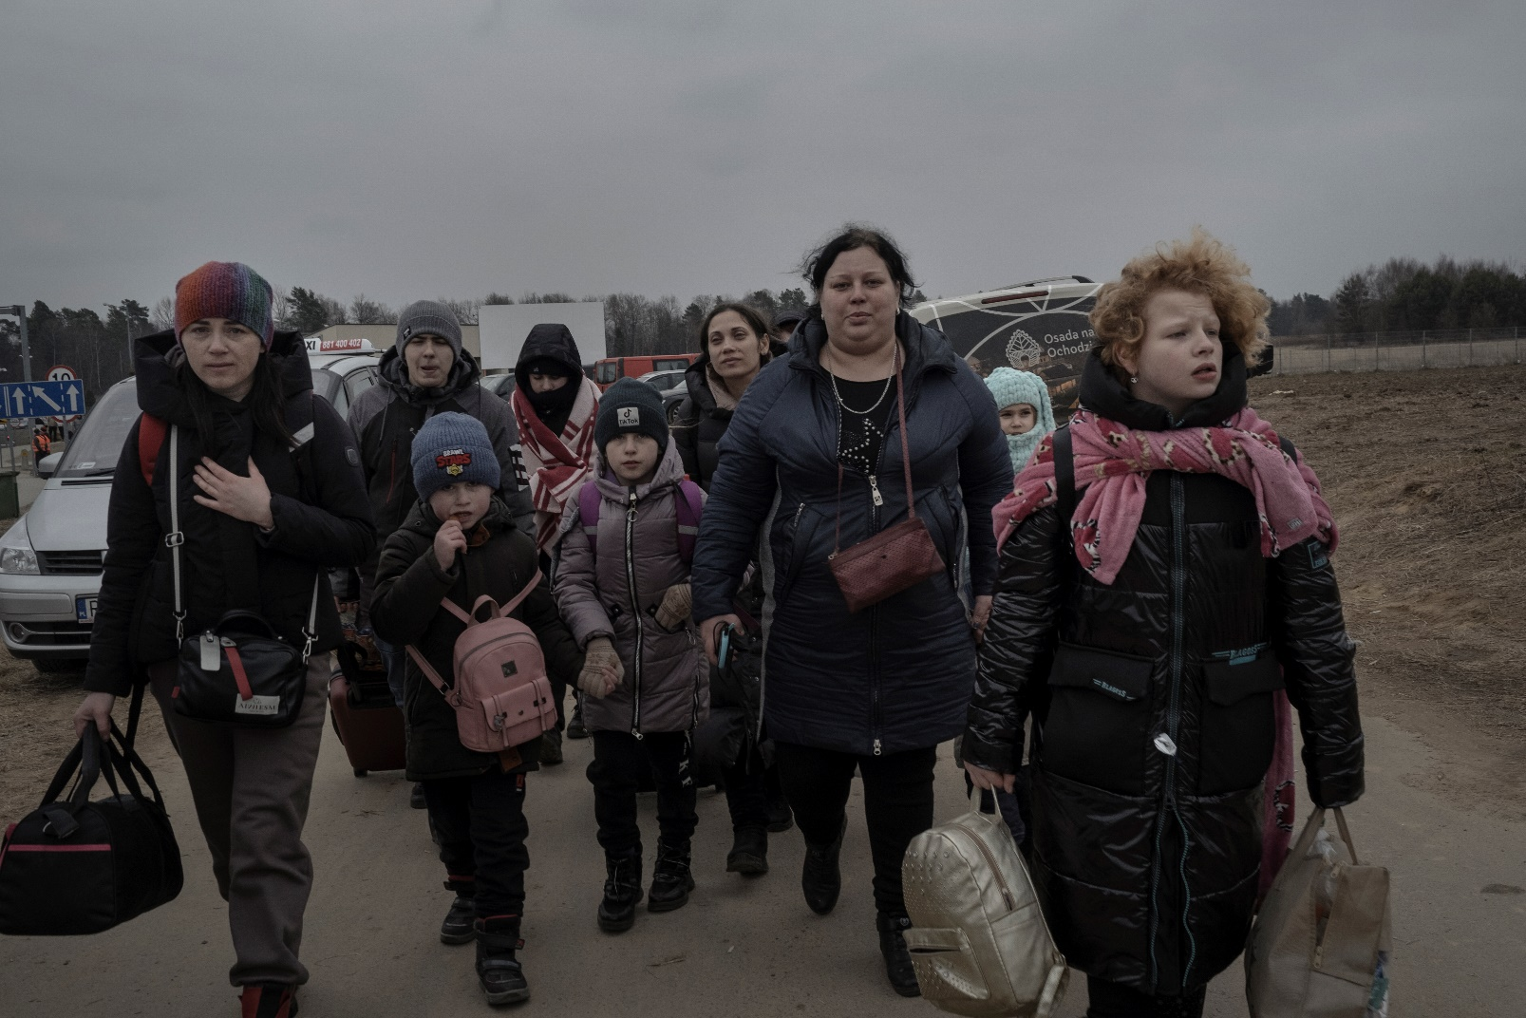

15 March 2022. Ukrainian refugees gather at Medyka border crossing point, Poland. Photo: Francesco Pistilli for IRC

March 18, 2022

Rescue.org

CULTURAL BACKGROUNDER FOR STAFF

**THE UKRAINIAN CRISIS AND REFUGEES FROM UKRAINE**

**CULTURAL BACKGROUNDER**

**THE UKRAINIAN CRISIS AND REFUGEES FROM UKRAINE**

This backgrounder contains information intended to cultivate a broad understanding of the crisis in Ukraine and the Ukrainian people who are fleeing the Russian invasion.

The information in this document is based on a variety of trusted resources, including articles and reports from The United Nations Refugee Agency (UNHCR), The U.S. Department of State, and The Foreign Policy Centre to the CDC. For a full list of resources used, please see the Bibliography.

**Overview of Crisis**

On February 24, 2022, the Russian military invaded Ukraine. The ongoing violence in Ukraine that has resulted from the invasion could become one of the worst humanitarian crises Europe has experienced in decades, with millions of people being forcefully displaced, both internally and internationally. As of March 16, 2022, UNHCR estimated that **3.2 million people** have fled to neighboring countries, including Moldova, Poland, Romania, and other regions in Europe.

3 March 2022. A mother and her daughter meet at the Medyka border crossing point, Poland. Photo: Francesco Pistilli for IRC.

# Timeline of Events

# The timeline below presents some of the key events that preceded Russia’s invasion of Ukraine and the current conflict.

|  |  |
| --- | --- |
| **2013-2014** | A series of large-scale Euromaidan protests led to the Revolution of Dignity, the overthrow of President Viktor Yanukovych, who, against the constituent’s decision, attempted to align with Russia in the Eurasian Economic Union instead of the European Union. |
|  | Russia invades and annexes the Ukrainian peninsula of Crimea. |
|  | The conflict intensifies in eastern Ukraine as Pro-Russian separatists begin seizing territory. |
|  | The Russian military crosses into Ukraine to support the separatist forces; as a result, violence intensifies near the border between Donetsk and Luhansk oblasts and Russia. |
| **2015** | Ukraine, France, Germany, and Russia sign the Minsk agreements for a ceasefire in the Donbas region, but the accords fail to resolve the war in Eastern Ukraine. |
| **2016-2017**  **2017** | A series of Russian cyberattacks on Ukraine’s power grids result in power outages and compromise government websites and systems.  An association agreement between Ukraine and the EU opens markets for free trade of goods and services, and visa-free travel to the EU for Ukrainians. |
| **2019** | A large majority elects Volodymyr Zelensky as the president of Ukraine on a promise to restore the country's territorial integrity and end the War in Donbas. |
| **2021** | Russia begins massing troops near Ukraine's borders in what it says are training exercises.  Russian President Vladimir Putin seeks to block Ukrainian NATO membership and ties with United States allies, seeing these connections as threats to its own economic and strategic security. |
| **2022** | Under the guise of conducting a “special military operation” intended to “denazify” and “demilitarize” Ukraine, Russia launched a full-scale military invasion of Ukraine, striking major cities with missile and artillery attacks. A humanitarian crisis and massive displacement unfold as conflict intensifies. |
|  |  |
|  | The war in Ukraine strains U.S.-Russia relations and increases the risk of a wider European conflict. |

# Map of Ukraine

Ukraine is the second largest country in Europe. Surrounded on the south by the Black Sea and the Sea of Azov, Ukraine shares borders with Belarus, Hungary, Moldova, Poland, Romania, Russia, and Slovakia.

## **Languages**

The country’s official language is Ukrainian, a Slavic language that uses a version of the Cyrillic alphabet. In 2001, 67.5% of Ukraine's population considered it their native language. Russian is the native language of 29.6% of Ukraine's population, and the rest (2.9%) are native speakers of other languages, including Romanian, Polish, and Hungarian.

Since the conflict between Ukraine and Russia began to escalate in 2013, the Ukrainian government made formal steps towards revitalizing the use of the Ukrainian language as the country's primary language, connecting it to national identity and cultural heritage. The State Language Law, passed in 2019, established Ukrainian as the country's primary language of communication in businesses, schools, and media.

**Culture**

Family is very important in Ukrainian culture, and extended family ties are valued. Couples often get married in their early 20s, and the average family has one or two children. Commonly, the grandmother is an esteemed and respected family member. It is common for young people to live with their parents until they get married or can afford their own home. Many elderly parents live with their adult children. In urban areas, both parents usually work outside the home, entrusting childcare either to grandparents or kindergarten and free after-school programs. In rural agricultural areas, many mothers may not have formal full-time jobs.

Single parenthood, specifically motherhood, is also prevalent in Ukraine. The divorce rate in Ukraine reached 3.1 divorces per 1,000 people in 2020, and children are often raised by mothers and grandmothers.

When meeting a friend or family member, both men and women greet each other with a handshake or a brief hug. People introduce themselves by their full name when meeting for the first time. The honorific Pan (Mr.) or Pani (Mrs.) may also be used when addressing an elder or other respected figure.

Ukrainian names are comprised of a first name (given name), a patronymic, and a last name (family name). The patronymic is formed by taking the father’s first name and adding “-vich” or “-ovich” for men, and “-avna,” “-ovna,” or “ivna” for women. In formal situations, people may either use their first name and patronymic, or honorific Pan/Pani and first name. With friends and close acquaintances, people may refer to each other by their first name or various nicknames, which are common for every Slavic name.

Hospitality is a staple of Ukrainian culture. Guests are warmly welcomed for a meal, and it may be seen as inconsiderate if they refuse the food. When visiting a home, it is polite to bring a gift like a cake or flowers. Flowers should only be given in odd numbers, and yellow flowers and white lilies should be avoided as they are used at funerals. It is considered impolite to point with one finger. Instead, it is best to use one’s whole hand to gesture.

National holidays include New Year’s Day (1st January), Christmas (7th January), International Women’s Day (8th March), Solidarity Day (1st May), Victory Day (9th May), Constitution Day (28th June), and Independence Day (24th August). Christmas is celebrated on January 7th, as many Ukrainian Christians observe the Julian Calendar from the Orthodox and Catholic traditions, but New Year’s Day is frequently the widely-celebrated winter event.

**Religion**

Orthodox Christianity is the principal religion in Ukraine. Approximately 62% of Ukrainians are Orthodox Christians, 9% are Greek Catholic, 1.5% are Protestant, 1.2% are Roman Catholic, 0.5% are Muslim, and 0.1% are Jewish. The All-Ukrainian Council of Churches and Religious Organizations (AUCCRO) serves as a platform for inter-religious dialogue and religious communication with the state.

Article 35 of the Constitution of Ukraine protects the full range of religious rights, and the separation of church and state.

## **Education**

Students can receive free general education in Ukraine. The school system includes 12 grades: four years of primary education, five years of secondary education (phase 1) and three additional, often optional years of secondary education (phase 2) after which students can select to get vocational training or academic study at a “lyceum”.

The academic year begins in September and concludes in June. All children aged seven to 15 must attend nine years of compulsory schooling. Some schools provide monthly stipends to students with high grades, starting from grade 5.

Post-secondary education can also be funded through the state, allowing students with good exam marks to receive education at no tuition cost with a scholarship that covers some basic needs. An undergraduate degree takes 3-4 years, postgraduate takes 1-2 years, with doctoral degrees taking an additional 3-5 years.

## **Employment**

In 2021, the employment rate in Ukraine was 66%, and the unemployment rate was 9%. The per capita income in Ukraine is approximately $13,260 USD. The main industries by which Ukrainians are employed include agriculture, aircraft plants, coal, electric power, machinery, chemicals, food processing, woodworking, and tourism. Top exports include cereals, iron and steel, fats and oils, iron ores, electrical equipment and parts, industrial machinery, and oil seeds.

## **Health**

## Ukraine has a universal healthcare system overseen by the Ministry of Healthcare. In 2017, a National Strategy on Health Reform was adopted to provide broader access to medical resources. According to law, healthcare should be free to all citizens, but it is common practice for patients to pay for medical appointments or labs.

## The life expectancy in Ukraine for females is 77 years, and 67 years for males. In 2020, Ukraine had an infant mortality rate of 7/1,000 live births.

## In addition to common healthcare practices and the use of pharmaceutical medicines, people may choose to see a folk healer for traditional remedies, specifically herbs and medicinal plants. This may also include rituals, prayers, and charms. Folk healers are an ancient cultural heritage in Ukraine.

## **Housing**

The majority of households in Ukraine live in cities (70%), with 10% of the population living in Kyiv. State-owned apartments are the most affordable type of accommodation, compared to private rented properties or owning an apartment or house. In cities, most families live in one- or two-bedroom apartments. While utilities such as electricity, gas, and water are available in cities, houses in rural areas might have simpler or no amenities, relying on wood and coal for heating.

**National Symbols**

The national symbols of Ukraine include the blue and yellow bicolour flag, signifying the skies and the wheat fields, the Coat of Arms/Tryzub, and sunflowers, the national flowers of Ukraine. “Slava Ukraini” (Glory to Ukraine) is now commonly used as greeting. In response, one may repeat the phrase or say “Geroyam Slava” (Glory to the Heroes).

**Resettlement Considerations**

**Average Case Size**

With most men ages 18 to 60 banned from leaving Ukraine, the majority of the refugees are women and children that were forced to separate from their husbands and father. Arriving in neighboring countries by evacuation trains or cars, some unaccompanied minors have also reached the borders by traveling with distant relatives or family members who returned to Ukraine after reaching the borders. Many families with emotional bonds to their pets were sheltering and evacuating with their dogs and cats. When resettling separated families, providers should be prepared to deal with concerns regarding family reunification, exercising a trauma-informed approach when addressing single parenthood and familial grief.

**Language**

The history of intentional elimination of a generation of Ukrainian language poets, writers, and artists of the1920s and early 1930s under Moscow-based Soviet rule, as well as official Russification efforts in 1932, creates complex and unique challenges Ukrainians might face in connecting to their traditional languages. While almost all Ukrainians speak and understand Russian as a second language, when working with individuals from the North and West parts of Ukraine, providers might choose to speak or use Ukrainian interpretation to establish better trust with the client. With Ukrainians from the South and East parts of the country, Russian interpretation might be more preferable. It is recommended that all providers approach the subject of language with care and understanding, ensuring appropriate interpretation is available for all migrants.

5 March 2022. A Ukrainian woman outside temporary shelter at Medyka border crossing point, Poland.  
Photo: Francesco Pistilli for IRC

**Physical and Mental Health**

In addition to expected injuries from shelling and missile attacks, refugees that fled Ukraine to neighboring countries might have trouble speaking about their trauma, stress, and history with depression, anxiety, and other psychiatric conditions. People, especially men, are deterred from discussing mental health in fear of being labeled as weak or dramatic. Alcoholism and other types of addictions are also prevalent and present long-term problems within the family unit. Service providers might start by asking about the physical symptoms of psychological stress and disorders such as insomnia, heart palpitation, weight loss or weight gain, etc.

Cardiovascular diseases, diabetes, tuberculosis, and COVID-19 are some of the other major health conditions that might impact the wellbeing of clients.

**Human Trafficking and Gender-Based Violence**

International and local organizations have raised concerns about human traffickers exploiting the large-scale displacement of vulnerable refugees, specifically women and children. Women have been advised to not accept transportation offers from unauthorized or suspicious people, only give copies, not original documents, to volunteers, and instruct children on how to seek help in case of kidnapping. Increased caution is required from all personnel, and providers may encounter troubles with establishing trust with survivors, witnesses, and other affected individuals.

**Documentation**

Most Ukrainians have physical copies of their national passport ID cards, travel passports, and birth certificates. However, practitioners should be aware that rapid evacuations during shelling and bombing attacks has meant that many people were forced to flee their homes without their most valuable possessions, including their proof of identity.

**LGBTQ+ Identity**

Although attitudes towards LGBTQ+ relationships and identities have been improving, homophobic and transphobic beliefs are still widespread, especially in rural and no-tourist areas. Ukraine has a 10-year history of Pride Marches, and labor laws were amended in 2015 to ban discrimination of LGBT people in the workplace, but same-sex couples are still ineligible for any legal protections available to opposite-sex couples.

On March 8th, 2022, the Russian Orthodox Church accused gay pride parades of being the reason for the war in Ukraine. LGBTQ+ refugees may experience more anxiety and grief about their peers left in Ukraine, feeling severe fear of human rights violations and persecution if Russia succeeds in occupying the country. Refugees might be cautious of speaking with caseworkers through native Ukrainian or Russian interpreters and may need additional encouragement and assurance of safety and non-discrimination.

**Other considerations**

While all Ukrainians have been subjected to the traumas of war, some communities are at a higher risk of oppression and violence by the Russian regime and may therefore experience additional stresses and challenges. Some ethnic groups that have historically been persecuted include Crimea Tatar, Roma, and Jewish people of Ukraine. International students, especially non-white individuals, members of the LGBTQ+ community, people with disabilities, independent journalists, and political activists, all have been threatened by Russian occupants and may be in greater danger.

# Additional Resources

# Books for historical context

# The Gates of Europe: A History of Ukraine by Serhii Plokhy

# Red Famine: Stalin’s War on Ukraine by Anne Applebaum

# Borderland: A Journey through the History of Ukraine by Anna Reid

# Ukraine’s Maidan Russia’s War: A Chronicle and Analysis of the Revolution of Dignity by Mychailo Wynnyckyj

# Absolute Zero by Artem Chekh

# Babi Yar: A Document in the Form of a Novel by A. Anatoli Kuznetsov

**Bibliography**

Ukraine Emergency, UNCHR, accessed March 2022, <<https://www.unhcr.org/en-us/ukraine-emergency.html?query=ukraine>>

UKRAINE: Timeline of Cyberattacks, Cyber Peace Institute, accessed March 2022, <<https://cyberpeaceinstitute.org/ukraine-timeline-of-cyberattacks/>>

Spoken Languages of Ukraine, Ukraine.com, accessed March 2022, <<https://www.ukraine.com/culture/languages/>>

2020 Report on International Religious Freedom, U.S. Department of State, accessed March 2022, <<https://fpc.org.uk/religion-and-forced-displacement-in-ukraine/>>

Religion and Forced Displacement in Ukraine, The Foreign Policy Center, accessed March 2022, <<https://www.euroeducation.net/prof/ukrco.htm>>

Ukraine Employment Rate, Trading Economics, accessed March 2022, <<https://tradingeconomics.com/ukraine/employment-rate#:~:text=Employment%20Rate%20in%20Ukraine%20averaged,the%20first%20quarter%20of%202017>>

CDC in Ukraine, CDC, accessed March 2022, <<https://www.cdc.gov/globalhealth/countries/ukraine/pdf/ukraine-2022.pdf>>

Public Housing Policy in Ukraine: Current State and Prospects for Reform, Cedos, accessed March 2022, <<https://cedos.org.ua/en/researches/derzhavna-zhytlova-polityka-v-ukraini-suchasnyi-stan-ta-perspektyvy-reformuvannia/>>

Some LGBTQ Ukrainians fear human rights abuses if Russia stays: "We will fight", CBS News, accessed March 2022, <<https://www.cbsnews.com/news/ukraine-lgbtq-fear-human-rights-abuses-if-russia-invades/>>

Russian Orthodox Church alleges gay pride parades were part of the reason for Ukraine war, CNN, accessed March 2022, <<https://www.cnn.com/europe/live-news/ukraine-russia-putin-news-03-08-22/h_de0516e0f59ac2214af21bbb0aaf152e>>

Thousands march in Ukraine for LGBT rights, safety, ABC News, accessed March 2022, <<https://abcnews.go.com/International/wireStory/thousands-march-ukraine-lgbt-rights-safety-80107859>>

In a terrible war of choices, these are the fighting-age men who left Ukraine, Washington Post, accessed 2022<<https://www.washingtonpost.com/world/2022/03/09/ukraine-men-leave/>>

How many refugees have fled Ukraine and where are they going?, BBC, accessed March 2022, <<https://www.bbc.com/news/world-60555472>>

Ukraine Government Laws, accessed March 2022, <<https://zakon.rada.gov.ua/laws/show/2704-19#Text>>

Distribution of the population of Ukraine’s regions by native language, Ukrainian Census, accessed March 2022, <[http://database.ukrcensus.gov.ua/MULT/Dialog/varval.asp?ma=19A050501_02&ti=19A050501_02.%20Distribution%20of%20the%20population%20of%20Ukraine`s%20regions%20by%20native%20language%20(0,1)&path=../Database/Census/05/02/01/&lang=2&multilang=en](http://database.ukrcensus.gov.ua/MULT/Dialog/varval.asp?ma=19A050501_02&ti=19A050501_02.%20Distribution%20of%20the%20population%20of%20Ukraine%60s%20regions%20by%20native%20language%20(0,1)&path=../Database/Census/05/02/01/&lang=2&multilang=en)>

New Language Requirement Raises Concerns in Ukraine, Human Rights Watch, accessed March 2022, <[https://www.hrw.org/news/2022/01/19/new-language-requirement-raises-concerns-ukraine#](https://www.hrw.org/news/2022/01/19/new-language-requirement-raises-concerns-ukraine) >

Registered divorce rate in Ukraine from 2000 to 2020, Statista, accessed March 2022, <<https://www.statista.com/statistics/1007126/ukraine-divorce-rate/>>

Prevention and control of infectious diseases in the context of Russia’s aggression towards Ukraine, European Centre for Disease Prevention and Control, accessed March 2022, <<https://www.ecdc.europa.eu/en/news-events/prevention-and-control-infectious-diseases-context-russias-aggression-towards-ukraine>>

* With mostly women and children fleeing Ukraine, European authorities fear a surge in human trafficking, Washington Post, accessed March 2022, <<https://www.washingtonpost.com/world/2022/03/17/human-trafficking-refugees-ukraine-war/>>
* Human trafficking experts: States must urgently protect refugees fleeing Ukraine, Council of Europe, accessed March 2022, <<https://www.coe.int/en/web/portal/-/human-trafficking-experts-states-must-urgently-protect-refugees-fleeing-ukraine>>